AI-Based Natural Language to SQL Query System
Basic idea: Normally, a person needs to know SQL to retrieve information from a database. For example: "Show all CSE students who scored above 80 marks."
The system uses AI to convert this sentence into SQL automatically.
Example: User enters: Find students whose attendance is below 75%.
AI generates:
SELECT StudentName, Attendance FROM Student WHERE Attendance < 75;

The DBMS executes the query and displays the result.
DBMS part
- Student database
- Course database
- Marks database
- Attendance database
- SQL queries
- Joins
- Views
- Constraints
- Database schema

AI part
- Natural Language Processing
- Large Language Model / NLP model
- Text-to-SQL generation

Workflow: User Question → AI → SQL Query → DBMS → Result
Algorithms/technology
- NLP
- Transformer/LLM
- Text-to-SQL

Output: A simple interface where students/faculty can ask questions in English instead of writing SQL.
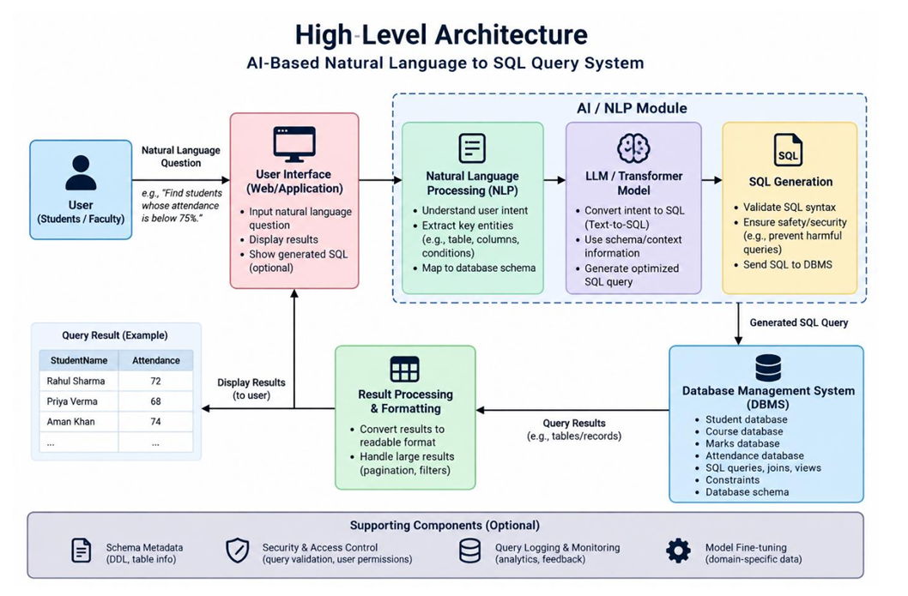

Latency- and Accuracy-Aware Schema Linking for LLM-Based Text-to-SQL Generation
Instead of giving LLM our entire database schema, we develop an algorithm that determines:
"For this question, which parts of the database schema actually matter?"
Then LLM only receives those relevant tables/columns.

Advantages of our improved concept:
- Reduced Token Consumption by the LLM
- More context space available to include
- Reduced Latency in the LLM output
- Improved overall efficiency of the system

Several measurable things to optimize:
- Accuracy
- Latency
- Prompt/token size
- API cost
- Schema-linking precision/recall
- SQL execution accuracy

Example User input: “Find me the names of employees whose salary is greater than 80,000.”
Current existing concept: send the entire Employee table schema to the LLM.
Our algorithm: only send the Employee Name, Salary to the LLM to generate the query.
Problem Statement:
Large Language Models can generate SQL queries from natural-language questions, but providing the complete database schema increases input complexity, inference latency, and the possibility of incorrect schema selection. This project investigates whether an intelligent schema-linking and reduction mechanism can improve Text-to-SQL generation accuracy while reducing computational and inference overhead.

if "attendance" in question: select attendance table. Too simple for real world scenario.
Hybrid schema-ranking algorithm:
For every table/column, calculate a relevance score:
Score(c,q)=​LexicalSimilarity+​SemanticSimilarity+​TypeMatch+​RelationshipScore

Research Papers
- Spider: A Large-Scale Human-Labeled Dataset for Complex and Cross-Domain Semantic Parsing and Text-to-SQL Task
https://aclanthology.org/D18-1425/
- Re-examining the Role of Schema Linking in Text-to-SQL
https://aclanthology.org/2020.emnlp-main.564/
- RAT-SQL: Relation-Aware Schema Encoding and Linking for Text-to-SQL Parsers
https://aclanthology.org/2020.acl-main.677/
- RESDSQL: Decoupling Schema Linking and Skeleton Parsing for Text-to-SQL
https://ojs.aaai.org/index.php/AAAI/article/view/26535
- Can LLM Already Serve as A Database Interface? A Big Bench for Large-Scale Database Grounded Text-to-SQLs
https://arxiv.org/abs/2305.03111

Quality of Service Parameters targeted to optimize:
Metric | Baseline | Proposed
Schema size | Full | Reduced
Prompt tokens | High | Lower
LLM latency | Measure | Measure
API response time | Measure | Measure
SQL accuracy | Measure | Measure
Execution accuracy | Measure | Measure
Schema-link precision | N/A | Measure
Schema-link recall | N/A | Measure
API cost | Higher | Lower
Local processing time | Very low | Slightly higher

